**Report on "Medical camp & Blood Donation Camp" held at Village Navagam (Nana), near to proposed Mithi virdi site Bhavnagar District on 25.12.2011**

NPCIL, Bhavnagar office organized a "Medical camp & Blood Donation Camp" at Village Navagam (Nana), Taluka:Ghogha, District:Bhavnagar. The medical camp was organized with support of Hope Foundation and Amardeep homeopathic college and voulantery blood donation camp was organized in association of Bhav vandana charitable trust and Bhavnagar blood bank. Required medicines were distributed to patients.

The year 2011-2012 is centenary year of Maharaja of Bhavnagar Shri Krishnakumarji who is very popular even today.

Above event was organized in memory of Maharaja. Wide publicity of camp was done in advance in following villages by way of distribution of handbill, display of banners, and scrolling of message in local TV channel. There was wide publicity through press note published as news item in local dailies.

|  |  |  |  |
| --- | --- | --- | --- |
|  |  | **Distance of** |  |
|  |  | **village from** |  |
| **Sr.** | **Village** | **proposed** | **Population** |
| **No.** | **Mithi virdi** |
|  |  |
|  |  | **site** |  |
|  |  | **(Km)** |  |
| 1. | Navagam | 5 | 1678 |
|  | (Nana) |  |  |
| 2. | Kukad | 5 | 2187 |
| 3. | Kantala | 3.5 | 2225 |
| 4. | Goriyali | 3 | 1563 |
| 5. | Chaniala | 7 | 937 |
| 6. | Bhankhal | 5.5 | 1172 |
| 7. | Garibpura | 6 | 2081 |
| 8. | Pithalpur | 5.5 | 925 |
| 9. | Odarka | 5.5 | 778 |

Inaugaration of camp done by Dr Kananib (Ex President - Bhavnagar Medical Association), sarpanch of village Navagam and other leaders of Navagam and surrounding villages. Hon. Mayor of Bhavnagar Shri. Sureshbhai Dhandhaliya, who is also President of Maharaja Shri Krishnakumarji Janma Shatabdhi Mahotsav Celebration committee could not be present due to other urgent program but conveyed his best wishes.

Doctors specialized in following branch provided services for medical camp.

* Orthopedic surgeon.
* Eye specialist.
* Physician.
* Pediatrician.
* Gynecologist.
* Homeopathy.

Total about 15 doctors provided services.

There was excellent response to medical camp. More than 500 patients took benefit of free consultation. Prescribed medicines were given free of charge by NPCIL. We found that people were very happy with services organized by NPCIL.

During welcome address, undersigned took opportunity to address need of nuclear plant and benefit of proposed nuclear plant to local people. We also explain them hoe nuclear power is safe and environment friendly. Literature about nuclear power was also distributed to people. We also gave photo of Maharaja Shri Krishmakumarji to all beneficiaries.

In Voluntary blood donation camp, total 21 units of blood was donated by donors.

At this occasion, NPCIL presented sport kit to school of Navagam.

Medical camp and blood donation camp was a grand success. NPCIL, Bhavnagar is planning such more medical camps in future.

P M Shah,

Chief Engineer, Bhavnagar.

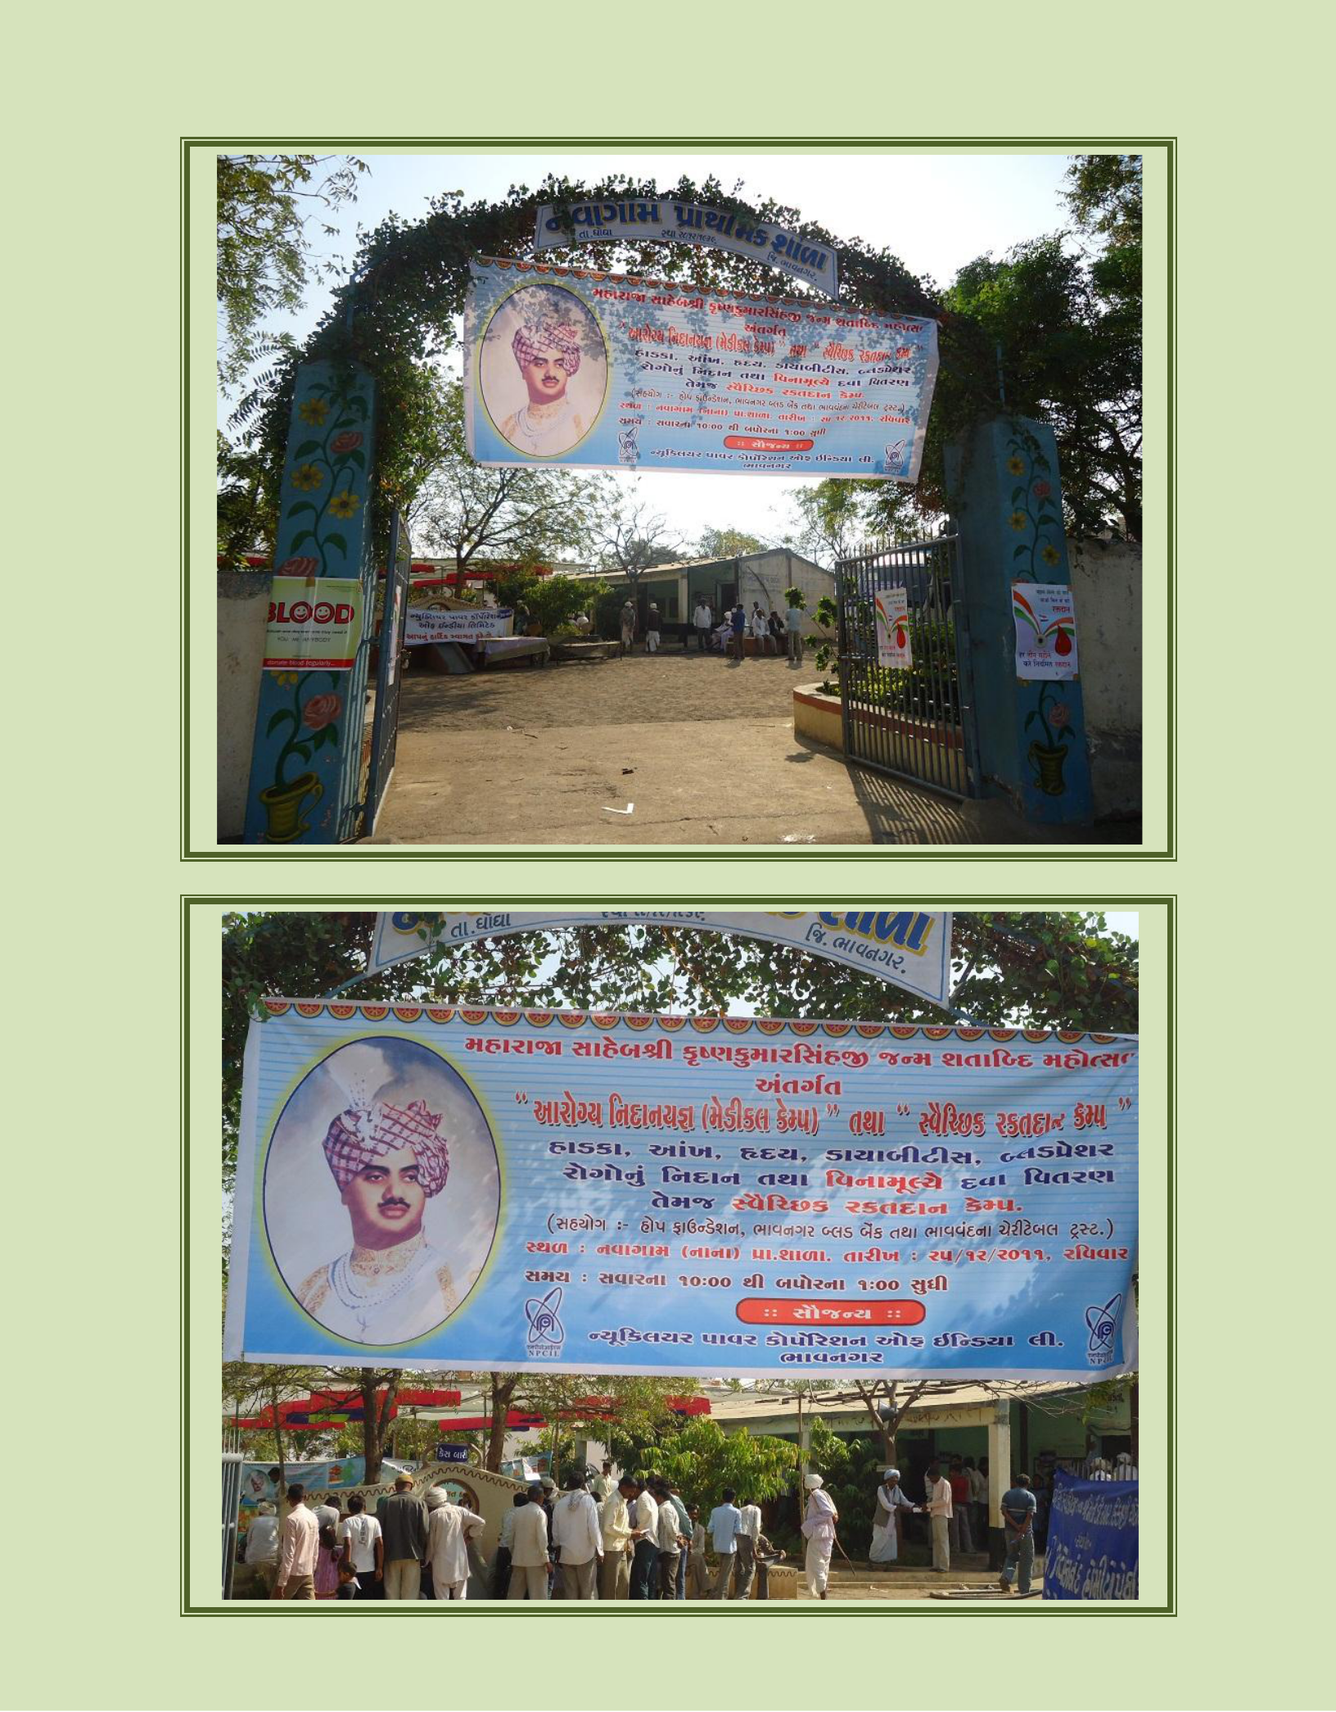Report on "Medical camp & Blood Donation Camp" held at Village Navagam (Nana), near to proposed Mithi virdi site Bhavnagar District on 25.12.2011

